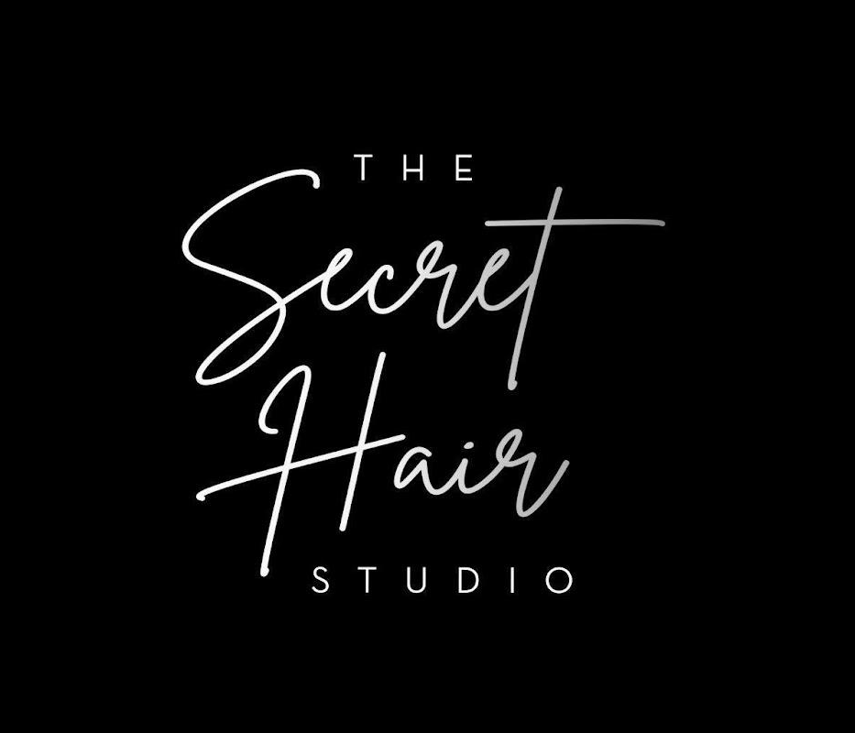

Bridal Contract & Information Guide
Congratulations on your engagement! We’re so excited for you and would be truly honored to be a part of your wedding day. This contract is designed to give you a clear understanding of what to expect—both before and on the day of your celebration.
If you have any questions at any time, please don’t hesitate to reach out to us. You can connect with our team by phone at (203) 456-6224 or by email at tiffany@thesecrethairstudio.com. We’re here to help make everything smooth and stress-free.

Services
- Consultation – Complimentary
- Bridal Trial – $200+
- Bride’s Hair* – $225+
- Flower Girls – $95+
- Bridal Blowouts – $100+
- Bridal Attendants – $165+
- Clip-in Extensions – Additional $40

Booking
To reserve your bridal party with us, we require a completed bridal contract with the following details:
- First and last names of each client
- Contact phone number for each client
- Requested services (and stylist, if preferred)

Before the Wedding: Let’s Talk
We highly recommend scheduling a bridal trial. This allows you to:
- Explore different styles and narrow down your final look.
- Share inspiration photos (styles you love and don’t love help equally!).
- Bring accessories or extensions you’ll be using, as well as photos of your dress to coordinate styles.
- Give your stylist the chance to get familiar with your hair type.
Bridal trials are available Tuesday–Friday until 3:00 PM.
We recommend scheduling any color or haircut appointments 1–2 weeks before your wedding for the best results.

The Day Before: Relax & Prepare
- Shampoo and blow-dry your hair with minimal product.
- Avoid flat irons or curling irons so your hair holds better on the big day.
- Remind your bridal party to follow the same steps.
- If services will be performed at a hotel, please confirm the room number with your stylist by the night before.

Wedding Day: It’s Finally Here!
- Do not wash your hair. (Blow-drying services are not included unless previously arranged.)
- Wear a zip-up, button-up, or wide-neck top to avoid disrupting your style.
- Arrive on time—late arrivals may delay the schedule and affect the finished look.
- Bring inspiration photos if you’d like to help guide your stylist.
We’re so excited to share in your special day and will do everything we can to make you feel beautiful, confident, and stress-free!

Bride & Wedding Details
- Today’s Date: ______________________
- Bride’s Name: ______________________________________
- Bride’s Contact Number: ____________________________________
- Bride’s Address: ________________________________________________________________________________
- Bride’s Email: ____________________________
- Wedding Planner’s Name: _______________________________________
- Planner’s Contact Number & Email: ________________________________________
- Wedding Date: ____________________________
- Wedding Start Time: __________ am/pm
- Time Bride must be finished: _____ am/pm
- Time Bridal Party must be finished: _____ am/pm
- Location of Services: ______________________________________
- Directions / Landmarks: ____________________________________
- Notes / Requests: ________________________________________
Party Size
- Bride: __________
- Mothers/Grandmothers: __________
- Bridesmaids: __________
- Flower Girls: __________
- Other Attendees: __________

Wedding Day Guidelines
- Attendees whose hair doesn’t hold typically start first. Styles are set and cooled before being pinned up.
- Bride and stylist will agree upon a start time. The bride is responsible for communicating timeliness and preparedness to the party. ______ (initial)
- Hair should be clean and dry unless otherwise discussed during the trial. Blow drying is not included unless arranged in advance. ______ (initial)
- Bride must confirm and commit to the number of services listed. Payment includes all listed services. Balance due in full on the wedding day. ______ (initial)
- Bridal party & guests must not show symptoms or recent exposure to COVID. Notify The Secret Hair Studio immediately if this changes. ______ (initial)

Photo Release
I, _______________________________, authorize The Secret Hair Studio to use my photos for websites, advertisements, and/or social media. ______ (initial)

Additional Fees
- Holiday Fee: $200 (applies to national holiday weekends) ______ (initial)
- Sunday Fee: $200 ______ (initial)
- Early Start Fee: $150 (before 6:30am) ______ (initial)
- Multiple Looks / Touch-Ups: $150 per hour ______ (initial)

Travel Fee
- 0–20 miles: Free
- 20–35 miles: $50
- 35–50 miles: $75
- 50–65 miles: $100
- 65+ miles: TBD (must be discussed; hotel accommodations may be required) ______ (initial)

Cancellation Policy
- Cancellations/changes allowed up to 30 days before.
- Within 2 weeks: 50% of total due.
- Day-of changes: full amount due for contracted services.

Final Totals
- Subtotal: $________
- Holiday/Sunday Rate: $________
- Mileage Fee: $________
- Final Total: $________

Final Payment Information
You can save your wedding date with a non-refundable $200 deposit (applied toward services).
Your card will only be charged with your permission for deposit or if contract terms are broken.
Visa ___ MasterCard ___ Amex ___ Discover ___
Name on Card: ____________________________
Card #: ____________________________
Exp Date: __________ CCV: ______ Zip: ______

Emergency Clause
If your stylist has a personal emergency, all efforts will be made to provide a replacement. If unavailable, all fees will be refunded.

Acknowledgement
This is a legally binding contract. By signing, you acknowledge and agree to all terms.
Bride: __________________________
Date: __________
Stylist: __________________________
Date: __________

